|  |
| --- |
| Circle Language Spec |

## Classes

### Main Concept

#### Concept

The* contents of an object can be totally arbitrary*. You* can put anything inside an object. This is handy for users, who just want to group objects together into a parent object, much like* they group together files in a folder.

However*, an object can also* select* another object to function as its *prototype*. A prototype is also* called a *class*. Classes describe the* rules by which objects behave. Objects of the* same* class contain* the* same* kinds of related items and related lists and also* support* the* same* commands.

An object will have the* same* *structure* as its class, but not the* same* data. The* values of the* attributes can freely change for each object. *Which* objects are referenced is also different* for each object. But* initially the* object will be an exact replica* of the* class. The* class’s attribute values and object references only function* as a default.

Any object can be used as a class. At first* there was the* idea, that an object could* be fixed* in its role as a prototype, but in that case* you* could not establish a reference to a class anymore.

There used to be* a misunderstanding* about something. When* an object does not have a class, it actually *does* *not* have a class. The* object can however* be *used* as a class. Formerly* this was mistaken for an object’s *defining* its own* class. But this is not true. An object without* a class *does not* define* its own class, *just* because* it can be *used* as one. An object, that does not have a class, also does not define its own class; it simply has no class assigned to it. Its contents are totally arbitrary*. *No class* stands for *arbitrariness\**.

You* have to keep that in mind. To understand why* you* have to keep that in mind, you* need a prime example of a case in which it becomes a problem.

For instance: the* article *Class Commands* introduces the* concept of *commands and classes loosely coupled*. It says, that when* a parameter gets a class, the* command will be available in every* object of that class. If* a parameter has no* class, it becomes a problem when you* think of that, as the* parameter’s defining its own* class. Because* in that case*, the* command will only* be available from objects, that point out *that* parameter* as their class. A strange situation. But the* real situation is, that a parameter without* a class, actually *has no\** class. That adds the* command to *any* object, because *no* class* stands for *arbitrariness*\*.

An object can be assigned a class. An object *reference* can also* be assigned a class. If* an object reference does not* have a class, then* the* object reference can point to *any\** object. That is another example of how *no* class* stands for *arbitrariness\**. When* an object or an object reference is assigned* a class, you* can not easily* change that class. If* an object has a class and you* assign another class to it, it would erase* the* object’s original contents. If* an object reference has a class, and it points to an object of that class, then* when* you* change the* class of the* object reference, what happens to the* target object, that still has the* original class? These are exceptional situations, for which the* most practical behavior needs to be determined in the* future.

#### Diagram Notation

Any* object can serve as another object’s class. So any* object can be the* prototype for another object.



When* you* actually use an object as another object’s class, then* its symbol is drawn with a dashed line. A dashed line stands for classes.



In a diagram a class will usually look like that.

If* a symbol, that functions as another object’s class, is also* referenced as an object, the* symbol gets a double border, indicating its dual function as both* an object and a class.



In fact it probably does not have a dual function, it is a class, but* there are also* *references* to the* class (established with an object redirection to the* class).

### Class Reference

An object’s specification of which* class it has, is also* called a class reference.

It is expressed in a diagram by connecting an object symbol to its class with a dashed line:



The* object on the* left has the* class on the* right.

### Class Commands

#### Concept

Objects of the* same* class have the* same* set of commands.

However*, commands are separate entities, not defined by a class.

When* a parameter of a command is not* given a specific class, then* the* command is available from any object.

This gives an object a lot of commands. But this will not* result in a mess, because* commands are nicely grouped* together inside the* object. Each module creates its own* group of commands inside an object. If* you* do not* trust a module: do not* use the* command.

So* when* the* class of a command parameter is not* fixed*, the* command is available from any* object. When* the* class of a command parameter *is* fixed*, this makes the* command only* available from objects of that class. This considerably limits the* amount of objects that get the* command.

In that sense* a *command* defines behavior of a class. Which makes sense* from a real-world point of view, because* you* can always invent new* ways to use an object.

A command is available from any* object that has anything to do with the* command.

#### Diagram Notation

The* article *Command Arguments in a Diagram* demonstrates, how a command argument also makes the* command part of* an object.

A command is executed on an object.



If* a command definition does not* fix the* class of one of its parameters, then* the* command will be immediately available from *any\** object. The* command will also* be visible in *any\** class.

Here is an example of a command definition, two objects and a class. One of the* objects has that class.

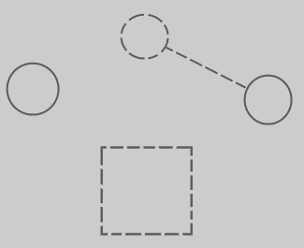

When a parameter is added to the* command, and the* parameter does not* have a class assigned to it yet*, the* following happens:

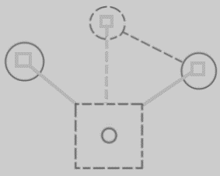

Because* the* command definition got a parameter with no* class assigned to it, the* command immediately becomes available from any* object or class in the* system. The* command symbols inside the* objects and the* class are tied to the* definition, to indicate mutuality of definition. Immediately the* command is very present in the* system, because* it can be executed on any object.

In theory*, all the* lines between the* squares could* have been drawn with a solid line. But the* *class* and the* *command definition* are tied together with a dashed line, because* it is a relation between structure elements. Now all structure elements and their relations are drawn out with dashed lines. It is more intuitive* that way.

If* you* assign a class to the* parameter, then* the* command will only* be available from objects of that class. The* command will also* only* be visible inside just* that class, not just* any class.

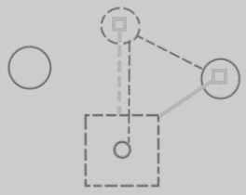

The* connection between the* class and the* command definition is now crowded with two lines. The* lines are merged together, to express the* tight bond* between the* command parameter and the* class command.

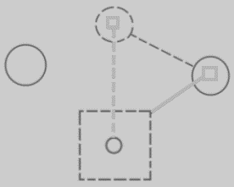

This also better expresses, that the* two directions of the* bidirectional relation between the* command and the* class are linked.

So in short*, this:



When* adding a parameter with a class, turns into* this:



What is visualized is, that the* system got expanded with a connection between the* class and the* command, which also* added the* command to the* only object of that class.

## Ideas about Classes Main Concept

Pointer to class of,

2008-08-17

Consider the* notation of pointing to the* class of an object reference, used in the* article Class Referrers in a Diagram.

I need a notation for explicitly referring to a pointer or to the* class of an object or to the* class of an object reference.

Do consider that the* target object in a diagram really needs to represents the* object. You* should not think of it as an object reference, because that will make it harder to see through the* system.

JJ

2004,

Every of those objects has a type. The* type determines the* contents of the* symbol. Every object of the* same type has the* same contents and the* contents of these objects changes simultaniously as you* edit it.

< 2008-10-12 That is no longer true. Objects of the* same class can have different contents. But what does change simultaneously, when you* edit the* class? >

JJ

Classes,

2009-05-12

Another synonym for class is *type*.

You* have to mention this somewhere.

JJ

Classes,

2008-11-13

If you* can see object usage, you* can not see class-sub-object usage.

You*'d have to look at the* usage of the* sub-objects of the* objects of that class,

to see the* class's sub-object usage. Indirectly you* will be able to see the* dependency on a class's sub-object.

Doesn't a sub-object have a reference to the* class's sub-object or does the* parent

object only have a reference to the* class?

JJ

Classes,

2008-11-26

The* remark below might give you* a clue about an exact sum-up of the* uses of classes. One of the* uses is having more than one of something. Another use is to selectively have none at all of something, so only a selection of things. Another use is being able to more easily reorganize separate units, if they are separate objects. Another use is being able to reference the* same thing from multiple places. That's not a use of classes, but a use of objects. Perhaps all of this is the* use of objects, not necessarily the* use of classes.

Om van projectfases losse units van te maken, in plaats van één document, kun je makkelijker de units schuiven en rangschikken en slechts een gedeelte van de fases gebruiken, en een fase meerdere malen hergebruiken, eigenlijk precies zoals je dat met classes doet.

JJ

Classes

2009-05-12

I do not know yet how to ventilate changes to classes to their derived objects.

JJ

## Ideas about Class Reference

Class reference,

2008-07-30

Right now I define class reference as being an object’s specification of what is its class.

But accidently I used class reference as a pointer to a class, as being analogus to a command reference.

JJ

### Out of the* original Symbol documentation

An object symbol can also serve as its own type:



Then it is an object that defines its own type. But if it has a type line, it redirects its type to another symbol. Then it is no longer its own type, but a mere object from an existing type, also called an instance of a type. The* target of the* type line is regarded the* type itself.



A is an instance, B is the* type.